**STATEMENT OF ENVIRONMENTAL EFFECTS**

**Twenty Five (25) Lot Industrial Subdivision**

**Lot 2 DP 838319 and part Lot 2 DP 1221837,**

**Wade Street, Coolamon**

**APPLICANTS: COOLAMON SHIRE COUNCIL**

**Executive Summary**

The application relates to the land known as Lot 2 DP 838319 and part Lot 2 DP 1221837, Wade Street, Coolamon. It proposes:

* A boundary realignment; and
* To subdivide 2 existing allotments into 25 allotments for light industrial land use purposes.

The proposed development will create light industrial land use opportunities for unused and vacant former railway land and will result in not only the sites but the immediate areas industrial activation.

The proposed development is in accordance with relevant statutory and non-statutory planning provisions.

1. **Introduction**

This Statement of Environmental Effects (SEE) has been prepared in accordance with the Environmental Planning and Assessment Regulation 2000, Schedule 1, Part 1, clause (2)(4). It responds to the relevant considerations under clause 4.15 of the Environmental Planning and Assessment Act 1979, as well as the Coolamon Local Environmental Plan 2011 and Coolamon Development Control Plan 2015.

It has been prepared to support a development application for the subdivision of 2 allotments into 25 allotments located at Lot 2 DP 838319 and part Lot 2 DP 1221837, Wade Street, Coolamon.

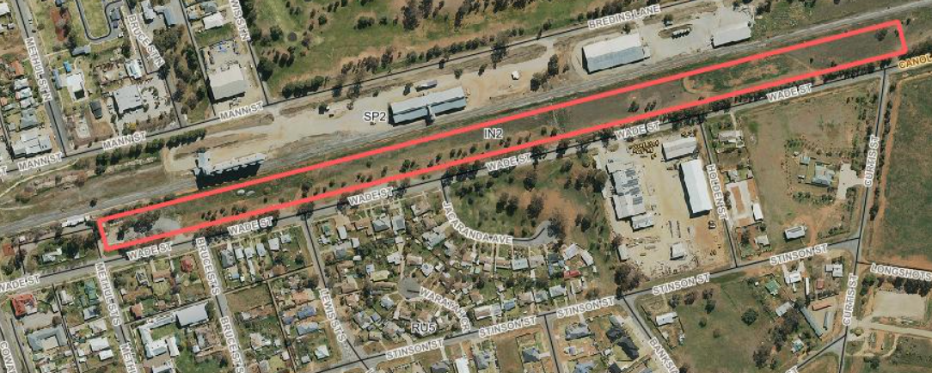

**Figure 1: Aerial image of the development site and adjoining area** (Source: Coolamon Shire Council Intramaps)

1. **Description of Works**

Council has amended the Coolamon LEP 2011 ‘Land Zoning Map and Lot Size Map Sheet’, and rezoned approximately six hectares of land at Lot 2 DP 838319, and about one hectare of land of part Lot 2 DP 1221837, Wade Street, Coolamon to light industrial. The proposed industrial development includes subdivision of the proposal site into 25 new light industrial lots that range in dimensions, all lots are a minimum of 2000 m2 (with exception of proposed easement allotments). The industrial subdivision includes the provision of services to all allotments in the form of power lines, drainage paths, water mains, sewerage mains and on street landscaping works.

Key development components:

* Subdivision of the proposal site into 25 smaller industrial lots
* Establishment of two easement/service lots to cater for power lines, drainage paths, water mains and sewerage mains
* Clearing of all vegetation, including mostly introduced groundcover, and some native, non-native, and non-locally native shrubs and trees from within lot boundaries
* Removal and limb-lopping of mature Sugar Gums (Eucalyptus cladocalyx), and minimal vegetation associated with remanent native vegetation to facilitate the construction of drive-way access to the lots.

It should be noted that all physical / civil infrastructure works associated with the subdivision are being carried out under Part 5 of the Environmental Planning and Assessment Act 1979. These works will be informed by an independent Review of Environmental Factors and a Biodiversity Assessment.

1. **Development Site & Locality**
   1. **Site Suitability**

The development site is known as Lot 2, DP 838319, and part Lot 2, DP 1221837, Wade Street, Coolamon.

The site lies between the Junee-Hay railway line to the north and Wade Street to the south.

The land has recently been rezoned from SP2 (Infrastructure) to IN2 (Light Industrial) with a minimum lot size 2,000 m2 minimum lot size.

Lot 2, DP 838319 is approximately 4.37 Ha in size (Owned by Coolamon Shire Council); and Part Lot 2, DP 1221837 (Owned by Transport for NSW) is the Junee – Griffith railway corridor with approximately 1 Ha of this lot being subject to this application. Transport for NSW have provided land owners consent – see attached letter.

The site is relatively flat and undulating and is not subject to any natural (flood or bushfire) or manmade hazards (contamination or subsidence etc.).

The site is surrounded by a mix of land uses, being railway corridor to the North, railway corridor to the east, residential land to the south and parkland to the west.

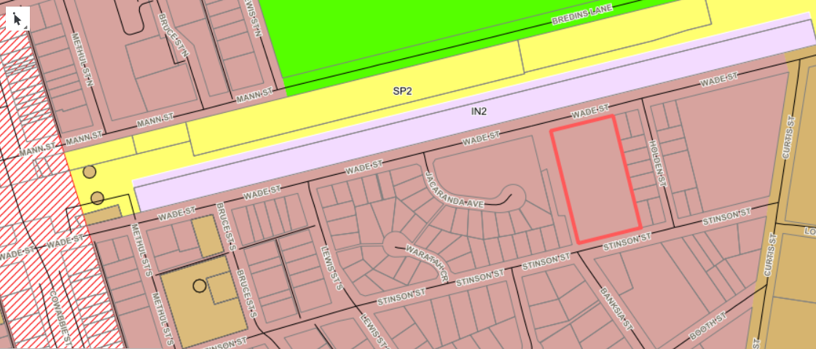

**Figure 2: Site Identification and Zoning Map**(Source: Coolamon Shire Council Intramaps)

* 1. **Current and Previous Uses**

The site is currently vacant and unused former Railway land which was previously owned by Rail NSW and which has been purchased by Coolamon Shire Council.

The subdivision of land proposed under this application is permitted with consent in the IN2 Light Industrial Zone under the provisions of the Coolamon Local Environmental Plan 2011 – see Clause 2.6.

* 1. **Proposed Subdivision**

The development proposes to subdivide 2 existing allotments into 25 allotments.

The proposed allotment sizes are as follows:

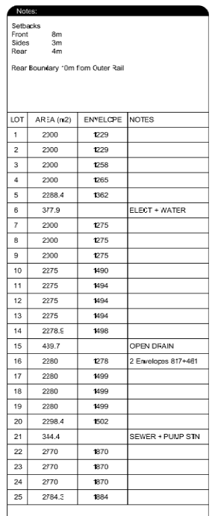

**Table 1: Allotment Sizes**

It is noted that 3 allotments that are proposed to be created via this application will be less than the prescribed minimum lot size (MLS) required for the IN2 Zone. The 3 allotments that will be under the MLS are proposed lot 6, lot 15 and lot 21.

These 3 allotments will be created for subdivision servicing purposes and will accommodate sewer, drainage, water and power infrastructure. The applicant requests the creation of these allotments under clause 4.6 (3) of the Coolamon Local Environmental Plan 2011 ‘Exceptions to development standards’ on the grounds that:

*(a) that compliance with the development standard is unreasonable or unnecessary in the circumstances of the case, and*

**Comment:** The requirement to create an allotment size of 2000 m2 is considered unnecessary to house the infrastructure to service the development. Lot sizes of 377.9 m2, 439.7 m2 and 344.4 m2 are considered ample and satisfactory to accommodate infrastructure required to service the development.

*(b) that there are sufficient environmental planning grounds to justify contravening the development standard.*

**Comment:** The creation of dedicated allotments to accommodate required infrastructure provides accessibility to relevant infrastructure authorities for servicing and maintenance of such infrastructure and minimises the need to create unnecessary burdens on freehold allotments that will be created under this development. The variation of the MLS development standard does not undermine the intent of the MLS provisions applying to this zone, it merely supports a more sustainable and orderly subdivision of land.

* 1. **Access and Traffic**

**Access**

The site has good access and fronts Wade Street.

Wade Street is a regional road under the control of Coolamon Shire Council and the road is a major transport route that provides access to, from and within the Shire for all vehicle types.

All proposed lots will be accessed via Wade Street and Council will ensure that all lots once purchased will have laybacks cut into the kerb and gutter (by Council engaged Contractor) and such laybacks will comply with access and construction requirements identified under the relevant provisions of the Coolamon DCP 2015.

The western end of the subject site is situated within approximately 400 metres of the main street shopping precinct and thus has adequate pedestrian access to commercial services.

**Traffic**

Whilst the subdivision proposal itself will not increase or create any adverse effects in relation to traffic, the future development that may occur on subdivided allotments will indeed result in increased traffic on the road and locality.

It should be noted that the development is located on Wade Street and that the road is a regional road under the control of Council. The road is currently well used and it is considered that the road and surrounding road network will satisfactorily cater for any future light industrial developments without creating adverse / unacceptable impacts.

The RTA Guide for Traffic Generating Development identifies that the peak traffic generation period for industrial land uses is generally determined by three key factors:

1. employee density,
2. travel mode and
3. peak period travel distribution.

The employee density will vary with the industry type - from a low density at traditional warehouses to a high density at high-tech industrial developments. The peak period travel distribution (i.e. the proportion of workers who travel to or from the site in the peak hour), varies with the type and extent of development. A single use factory generally has a higher proportion of workers travelling in the peak hour than a factory unit development, where different employees have different work patterns. As work patterns continue to overlap, the percentage of those travelling in the peak hour declines.

The generation rates given below are for single use developments. Lower rates might be appropriate for multiple-use developments, as discussed above. Anticipated vehicle movement rates as per the RTA Guide for industrial development is:

* Daily vehicle trips = 5 per 100 m2 gross floor area
* Evening peak hour vehicle trips = 1 per 100 m2 gross floor area.

Noting that there will be 21 development lots created under the subdivision, if we anticipate that maximum building footprint, on average will be 450 m2 per lot, we can then can estimate that the subdivision will create 4.5 daily movements per lot.

21 allotments x 4.5 traffic movements = 94.5 traffic movements per day. Rounded up to 100 traffic movements per day for the allotments created (21).

It is envisaged that the vehicle types that will access allotments in the future will include cars, pantec trucks, other service vehicles and on occasion A – doubles (maximum of 30 metres). The regional road (Wade Street) and surrounding network is considered satisfactory in being able to cater for such vehicle types.

Future development of the subdivided allotments will undoubtedly increase the amount of vehicular traffic to the site/immediate area when compared to the traffic generated from the existing site status (vacant). The impact of an additional 100 traffic movements per day on a regional road is considered acceptable and it is considered that the road and surrounding road network will satisfactorily cater for any future light industrial developments without creating adverse or unacceptable impacts to the road network or the amenity of the surrounding area.

Traffic impacts will also be further assessed under future development applications for individual developments on the created allotments.

The development is not traffic generating development as defined under the State Environmental Planning Policy (Infrastructure) 2007, as it will not result in:

|  |  |  |  |
| --- | --- | --- | --- |
| **Purpose of Development** | **Size or capacity—site with access to a road (generally)** | **Size or capacity—site with access to classified road or to road that connects to classified road (if access within 90m of connection, measured along alignment of connecting road)** | **Comment** |
| Industry | 20,000m2 in site area or (if the site area is less than the gross floor area) gross floor area | 5,000m2 in site area or (if the site area is less than the gross floor area) gross floor area | The lots sizes proposed cannot accommodate a building of these sizes. |
| Subdivision of land | 200 or more allotments where the subdivision includes the opening of a public road | 50 or more allotments | The subdivision is for the creation of 25 lots. |
| Any other purpose | 200 or more motor vehicles per hour | 50 or more motor vehicles per hour | 21 usable allotments x 4.5 traffic movements = 94.5 traffic movements per day. Rounded up to 100 traffic movements per day for the allotments created (21). |

**Table 2: Assessment against Schedule 3 of SEPP Infrastructure**

**Parking and Loading / Unloading**

The subdivision will not create any adverse effects in relation to Parking and Loading / Unloading.

Adequate off-street parking is the main criterion in the assessment of parking areas provided for developments. Adequate provision of off-street parking discourages on-street parking, thereby maintaining the existing levels of service and safety of the road network.

All future developments will be required to ensure compliance with the following development controls applying to Industrial Development, which are contained in the Coolamon Development Control Plan 2015:

* Vehicular entry and exit shall be in a forward direction, with vehicular access points located clear of rail crossings, roundabouts and intersections. Access points with inadequate sight distances should also be avoided.
* Internal manoeuvring and parking areas shall be constructed to be hard-wearing and be provided with a dust-proof surface.
* Internal parking spaces shall be clearly delineated.
* The number of car parking spaces shall be determined in reference to the NSW Roads and Maritime Services Guide to Traffic Generating Development and Australian Standard 2890 – Parking Facilities. Any variation will be at the full discretion of Council.
* The loading and unloading of delivery vehicles shall be contained wholly on site. All loading/unloading on public roads will not be permitted.
* Subdivided allotments will be required, under the auspices of individual development consents to provide adequate parking, loading and unloading facilities on each allotment. Such matters will be

The subdivision will also result in the provision of kerb and gutter along the Wade Street Development frontage and there will be ample opportunity for on street parking if required.

**Pedestrians and Cyclists**

The structure and coverage of the pedestrian network surrounding the development is considered to be satisfactory and promotes a high degree of accessibility to the site / allotments.

* 1. **Air and Noise**

The proposal will result in minimal impacts in regard to air and noise.

The development will not result in any adverse air pollution outcomes and nor does the development utilise processes or activities that would create any adverse air impacts.

Any noise impacts associated with the development would be related to future operational activities and would be consistent with the noise generated from light industrial land uses. The subdivision application itself does not promote any air or noise impacts.

All subdivision civil construction works are being carried out under Part 5 of the Environmental Planning and Assessment Act 1979. Such works include:

* Establishment of two easement/service lots to cater for power lines, drainage paths, water mains and sewerage mains
* Clearing of all vegetation, including mostly introduced groundcover, and some native, non-native, and non-locally native shrubs and trees from within lot boundaries
* Installation of sewer, water, electricity and stormwater infrastructure
* On street landscaping works
* Removal and limb-lopping of mature Sugar Gums (Eucalyptus cladocalyx), and minimal vegetation associated with remanent native vegetation to facilitate the construction of drive-way access to the lots.
  1. **Privacy, views and overshadowing**

The development will not result in any adverse or unacceptable impacts to privacy, views or create overshadowing issues.

The land is zoned IN2 Light Industrial and whilst it adjoins existing residential development such issues will be regulated via all future developments being assessed under individual development applications and requiring such applications to comply with the controls identified under Section 28. ‘Commercial and Industrial Development’ of the Coolamon Development Control Plan 2015.

* 1. **Soil and Water**

Storm water drainage, sewerage, reticulated water and power will be provided to service the site and all proposed allotments.

Stormwater will be addressed via kerb and gutter that will be provided from the frontage of proposed lot 1 up until lot 15. From lot 15 through to lot 25 stormwater will be addressed via a table drain system.

All civil works will be carried out under Part 5 of the Environmental Planning and Assessment Act 1979 and a construction environmental management plan (CEMP) would guide construction activities to ensure works are carried out to Council specifications and to incorporate all safeguards described in the ecological assessment and other supporting documents including the Review of Environmental (REF) and erosion and sediment control plan.

* 1. **Waste**

No waste will be generated as a result of this subdivision application.

* 1. **Contaminated Land Considerations**

McMahon Earth Science (McMahon) was engaged by Coolamon Shire Council to undertake an initial inspection, investigation and contamination assessment of vacant block of land at Lot 2 DP 838319 Wade Street Coolamon (the site) on 8 October 2019.

The report concludes that from the available information there is no qualitative or quantitative evidence of previous contaminating activities nor gross surface or subsurface soil contamination on site and the site is considered suitable for development as commercial/industrial land.

**Relevant Environmental Planning Instruments**

* 1. **State environmental Planning Policies**

*State Environmental Planning Policy No 55* – Remediation of Land is relevant to this development.

This SEPP aims to promote the remediation of contaminated land for the purpose of reducing the risk of harm to human health or any other aspect of the environment:

*(a) by specifying when consent is required, and when it is not required, for a remediation work, and*

*(b) by specifying certain considerations that are relevant in rezoning land and in determining development applications in general and development applications for consent to carry out a remediation work in particular, and*

*(c) by requiring that a remediation work meet certain standards and notification requirements*

This SEPP requires that Council (consent authority) must not consent to the carrying out of any development on land unless:

(*a) it has considered whether the land is contaminated, and*

*(b) if the land is contaminated, it is satisfied that the land is suitable in its contaminated state (or will be suitable, after remediation) for the purpose for which the development is proposed to be carried out, and*

*(c) if the land requires remediation to be made suitable for the purpose for which the development is proposed to be carried out, it is satisfied that the land will be remediated before the land is used for that purpose.*

*(2) Before determining an application for consent to carry out development that would involve a change of use on any of the land specified in subclause (4), the consent authority must consider a report specifying the findings of a preliminary investigation of the land concerned carried out in accordance with the contaminated land planning guidelines.*

*(3) The applicant for development consent must carry out the investigation required by subclause (2) and must provide a report on it to the consent authority. The consent authority may require the applicant to carry out, and provide a report on, a detailed investigation (as referred to in the contaminated land planning guidelines) if it considers that the findings of the preliminary investigation warrant such an investigation.*

*(4) The land concerned is:*

*(a) land that is within an investigation area,*

*(b) land on which development for a purpose referred to in Table 1 to the contaminated land planning guidelines is being, or is known to have been, carried out,*

*(c) to the extent to which it is proposed to carry out development on it for residential, educational, recreational or child care purposes, or for the purposes of a hospital-land:*

*(i) in relation to which there is no knowledge (or incomplete knowledge) as to whether development for a purpose referred to in Table 1 to the contaminated land planning guidelines has been carried out, and*

*(ii) on which it would have been lawful to carry out such development during any period in respect of which there is no knowledge (or incomplete knowledge).*

The justification has been provided via the undertaking of a site contamination assessment by a suitability qualified testing authority. The application has demonstrated that the proposal for the site is suitable when assessed against the provisions of this SEPP.

* 1. **Coolamon Local Environmental Plan 2011**

**Part 2 Permitted or Prohibited Development**

The subject land is zoned IN2, under the provisions of the Coolamon Local Environmental Plan (CLEP) 2011, as illustrated in the Figure 3 below.

The subdivision of land is permitted with consent under clause 2.6 of the CLEP 2011.

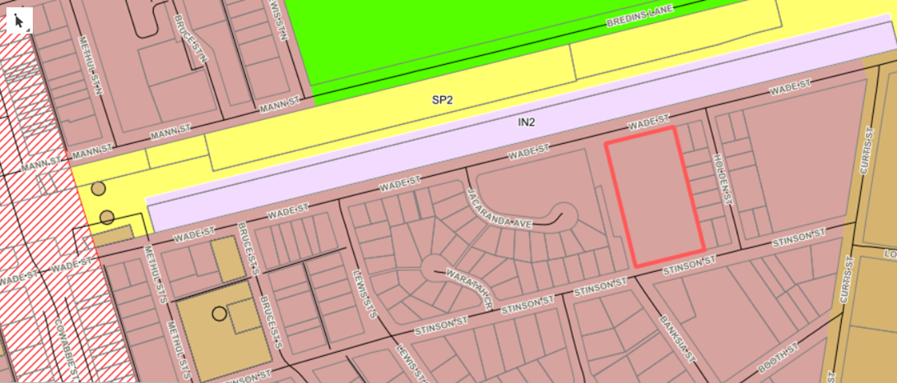

**Figure 3: CLEP 2011 Zoning Map of development site and surrounds** (Source: Coolamon Shire Council Intramaps)

The IN2 Light Industrial Land use Table permits and prohibits the following development types:

*Permitted with consent -*

Depots; Freight transport facilities; Funeral homes; Garden centres; Hardware and building supplies; Industrial training facilities; Kiosks; Landscaping material supplies; Light industries; Liquid fuel depots; Neighbourhood shops; Oyster aquaculture; Places of public worship; Plant nurseries; Recreation facilities (indoor); Rural supplies; Self-storage units; Take away food and drink premises; Tank-based aquaculture; Timber yards; Vehicle repair stations; Vehicle sales or hire premises; Veterinary hospitals; Warehouse or distribution centres

*Prohibited -*

Pond-based aquaculture; any other development not permitted with consent.

The objectives of the IN2 Light Industrial zone are;

|  |  |
| --- | --- |
| Zone Objectives | Comments |
| To provide a wide range of light industrial, warehouse and related land uses. | The objective is achieved as the proposal will create allotments that will promote a range of future land uses identified in the objective. |
| To encourage employment opportunities and to support the viability of centres. | The objective is achieved as the subdivision proposal will create allotments that will generate many employment opportunities in a very accessible location that will support the future viability of the Coolamon Township. |
| To minimise any adverse effect of industry on other land uses. | The objective is achieved as the proposed subdivision is situated on major transport route with sufficient distance provided between existing and surrounding land uses. |
| To enable other land uses that provide facilities or services to meet the day to day needs of workers in the area. | The objective is achieved as the proposed development provides for the ability of future land uses to be located on the subdivided allotments to service the needs of workers in the area. |
| To support and protect industrial land for industrial uses. | The objective is achieved as the proposed subdivision will ensure that land is created for the dedicated purpose of light industrial land uses and activities. |

**Table 3: IN2 Zone Objective Assessment**

**Part 3 Exempt + Complying Development**

The development is not exempt or complying development as provided for under the CLEP or any other plan or policy.

**Part 4 Principal Development Standards**

There is one clause, clause 4.1, that the proposal does not comply with.

The application relies on the provisions contained in clause 4.6 of the CLEP to address this matter.

As previously identified, it is noted that 3 allotments to be created via this application will be less than the prescribed minimum lot size (MLS) required for the IN2 Zone. The 3 allotments that will under the MLS are proposed lot 6, lot 15 and lot 21.

These 3 allotments will created for subdivision servicing purposes and will accommodate sewer, drainage, water and power infrastructure. The applicant requests the creation of these allotments under clause 4.6 (3) of the Coolamon Local Environmental Plan 2011 ‘Exceptions to development standards’ on the grounds that:

*(a) that compliance with the development standard is unreasonable or unnecessary in the circumstances of the case, and*

**Comment:** The requirement to create an allotment size of 2000 m2 is considered unnecessary to house the infrastructure to service the development. Lot sizes of 377.9 m2, 439.7 m2 and 344.4 m2 are considered ample and satisfactory to accommodate infrastructure required to service the development.

*(b) that there are sufficient environmental planning grounds to justify contravening the development standard.*

**Comment:** The creation of dedicated allotments to accommodate required infrastructure provides accessibility to relevant infrastructure authorities for servicing and maintenance of such infrastructure and minimises the need to create unnecessary burdens on freehold allotments that will be created under this development. The variation of the MLS development standard does not undermine the intent of the MLS provisions applying to this zone, it merely supports a more sustainable and orderly subdivision of land.

**Part 5 Miscellaneous Provisions**

No clause in this part applies to the subject development.

**PART 6 ADDITIONAL LOCAL PROVISIONS**

Clause 6.4 ‘Essential Services’ applies to this development. All essential services will be provided to this development and thus the development satisfies the provisions of this clause.

1. **Relevant Development Control Plans** 
   1. **Coolamon Development Control Plan 2015**

The proposed development falls under the provisions of the Coolamon Development Control Plan (CDCP) 2015. The development complies with all relevant considerations and controls provided for under this plan.

1. **Statement of Environmental Effects – Likely Impacts**

The likely impacts of the development are considered below.

|  |  |  |  |  |
| --- | --- | --- | --- | --- |
| **Section 79C(1)(b) Schedule – likely impacts of the development** | | | | |
|  | **Satisfactory** | **Not Satisfactory** | **Not**  **applicable** | **Comments** |
| **Context + setting** | **✓** |  |  | It is considered that the proposal does not create any adverse impacts on the context and setting of the site.  The site was formerly disused railway land adjoining railway line, which is now zoned light industrial and will be subsequently utilised for light industrial land use purposes. |
| **Streetscape** | **✓** |  |  | The development for subdivision will not change the way the existing / subdivided site interacts or presents to the street in any adverse way. If anything, the proposal will enhance the way the site presents to the street via the introduction of significant on street landscaping works. |
| **Traffic, access + parking** | **✓** |  |  | There is no anticipated adverse or unmanageable traffic or parking impacts resulting from this development. The development site fronts a regional road under Council control and this road and adjoining traffic network is considered suitable for intended future light industrial land uses on the subdivided land. |
| **Public domain** | **✓** |  |  | The development will create positive interactions with the public domain, the site is currently unused and thus there is no public domain interactions. Once the development is implemented, i.e. land uses approved on subdivided allotments there will be positive public domain interactions as customers and workers access a previously unused site from the public realm via a heavily landscaped street. |
| **Utilities** | **✓** |  |  | There are no unacceptable impacts to public utilities. The development has access to all required services and these will be provided to all sites under a part 5 development/activity process. |
| **Heritage** | **✓** |  |  | There is no known European or Aboriginal heritage value associated with the site. |
| **Other land resources** | **✓** |  |  | The development will have no adverse impacts on other land resources. |
| **Water quality + stormwater** | **✓** |  |  | The development is not anticipated to have a long term impact on water quality. Stormwater discharge will not be affected by the proposal. Any upgrades to existing stormwater infrastructure will be carried out in accordance with the stormwater management plans approved and implemented under a part 5 activities process. |
| **Soils, soil erosion** | **✓** |  |  | No building works are being proposed and thus no soil impacts or soil erosion measures are required. |
| **Air + microclimate** | **✓** |  |  | The development, for the purpose of subdivision, is not anticipated to have adverse impacts on air and microclimate. |
| **Flora + fauna** | **✓** |  |  | There are no anticipated unacceptable impacts on flora and fauna from the development proposal. Please see attached Biodiversity Assessment Report prepared by GHD. |
| **Waste** | **✓** |  |  | No waste is to be generated as part of this development application. Construction waste will be generated via the works that will be undertaken under Part 5 of the EPA 1979 to service the development. The waste that will be generated will be in the form of construction waste and earthworks, such works and any waste generated will be managed via a construction and environmental management plan. |
| **Noise + vibration** | **✓** |  |  | The subdivision will not create any noise or vibration. The subdivision itself will not result in any noise or vibration works. There will be noise and vibration impacts associated with the works carried out under civil work activities that are to be conducted under Part 5 of the EPA Act 1979. The Part 5 works will be notified to adjoining land owners and managed in accordance with the construction and environmental management plan for the site. |
| **Hours of operation** | **✓** |  |  | Not applicable. Civil works that will be undertaken for the subdivision under a Part 5 EPA pathway will be undertaken between the hours of 7 am – 3.30 pm Monday to Friday and the details of such works will be communicated to adjoining landowners |
| **Natural hazards**  **(flood + bushfire)** | **✓** |  |  | The development site is not bushfire prone or flood prone. |
| **Technological hazards** | **✓** |  |  | The development is not likely to create any unacceptable technological hazards. |
| **Safety, security + crime prevention** | **✓** |  |  | No adverse safety and security impacts are anticipated as a result of the proposal. |
| **Socio-economic impact in the locality** | **✓** |  |  | The proposed subdivision will create opportunity for the future development of lots created and future development works will generate positive economic benefits / impacts resulting in employment of local and regional and staff to operate the completed future developments – all this will provide positive economic flow on effects to the local and regional economy.  The development will promote no adverse social impacts, it will not impinge on peoples social or political rights or beliefs and nor will it change the way people carry out their lives. |
| **Site design + internal design** | **✓** |  |  | The subdivision design is considered to be appropriate for its intended use. Any future development proposals will be assessed and required to comply with the Industrial Development Controls listed under Section 28 ‘Commercial and Industrial Development’ of the Coolamon Development Control Plan 2015. |
| **Overlooking + overshadowing** | **✓** |  |  | Not applicable – no structures are being erected under the banner of this application. Future development will have no overlooking or overshadowing impacts as there is and will be sufficient buffer distances to existing and proposed developments. |
| **Landscaping** | **✓** |  |  | The proposed development will be enhanced by significant on street landscaping works that will be carried out as part of the Part 5 Activities.  For further details refer to the concept landscape plan attached. |
| **Construction** |  |  | **✓** | All civil construction work is being carried out by Council as the land owner and developer and will be undertaken as a part 5 Activity. |
| **Private open space** |  |  | **✓** | Not applicable to the proposal. |
| **Cumulative impacts** | **✓** |  |  | The cumulative impact of the development is considered positive. |
| **Disabled access** |  |  | **✓** | Not applicable. |
| **Signage** |  |  | **✓** | Not applicable. |
| **Setbacks + building envelopes** |  |  | **✓** | Not Applicable. However, the subdivision will create building envelopes via Section 88 b Instrument for all allotments to ensure that required building setbacks are achieved in accordance with relevant DCP provisions. |
| **Public Interest** | **✓** |  |  | The Township of Coolamon has over a period of time witnessed a significant increase in development types such as mechanics (vehicle repair station), cabinet / joinery makers, plumbers and other trades (light industrial), landscaping businesses (landscape and garden supplies) seeking to establish their respective developments on land that is zoned RU5 Village or RU4 Rural Small Holdings. Whilst the scale of some of these businesses may be carried out under a Home Business or Home Industry Land Use definition, it is considered for such developments that do not meet relevant LEP controls, the provision of light industrial land would be more appropriate and suitable and serve to reduce the potential for any land use conflict. The development application will create 21 light industrial allotments that will have social, environmental and economic benefits to the town and wider shire.  As such the proposed development is considered to be in the public interest. |

1. **Summary**

This Statement of Environmental Effects (SEE) has been prepared to support a development application for the subdivision of 2 allotments into 25 allotments located at Lot 2 DP 838319 and part Lot 2 DP 1221837, Wade Street, Coolamon

The development is consistent with the land use zoning of the site and its surrounds.

The development is not anticipated to have any adverse environmental impacts. Whilst all development has impacts, the impacts associated with this development will be effectively managed to mitigate and reduce any negative impacts.

The development is permissible with consent in the IN2 Light Industrial Zone and achieves the objectives of the zone. The development can be approved by Council, subject to a merits assessment.

**Attachments**

1. Site Contamination Assessment Report by McMahon Earth Sciences.
2. Concept Subdivision Plan prepared by Coolamon Shire Council.
3. Concept Streetscape Plan prepared by Coolamon Shire Council.
4. Coolamon industrial subdivision Biodiversity assessment prepared by GHD.
5. Review of Environmental Factors – prepared by GHD. This was prepared to support Part 5 Activities – civil works.